Children’s Ministry on Church Web Page

Currently, we are meeting on Facebook Live each Friday at 10:00 am for children’s Bible lessons. If you can’t join us Live the lessons can be found under the videos tab of our church Facebook page. These lessons are also emailed out to families. If you would like to be added to email list please contact Liz Lentz at [liz@psjumc.org](mailto:liz@psjumc.org). We look forward to playing and worshiping Christ together as soon as possible.

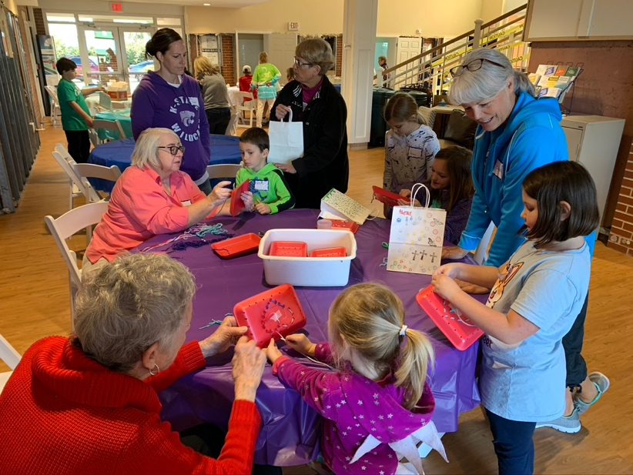

Winter Art Party

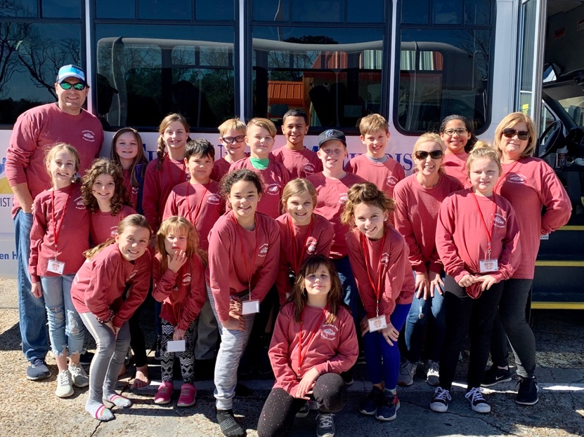

Blue Lake Winter Retreat

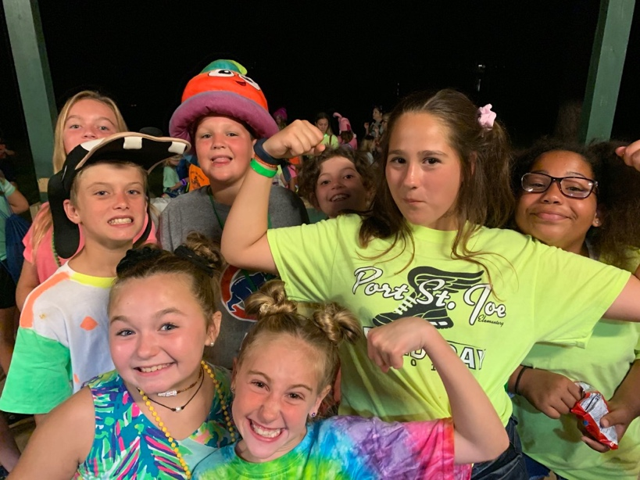

Blue Lake Summer Camp

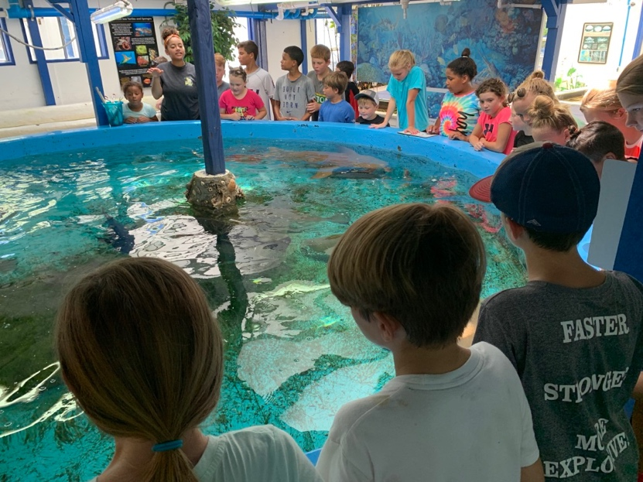

Wacky Wednesday Summer Trips

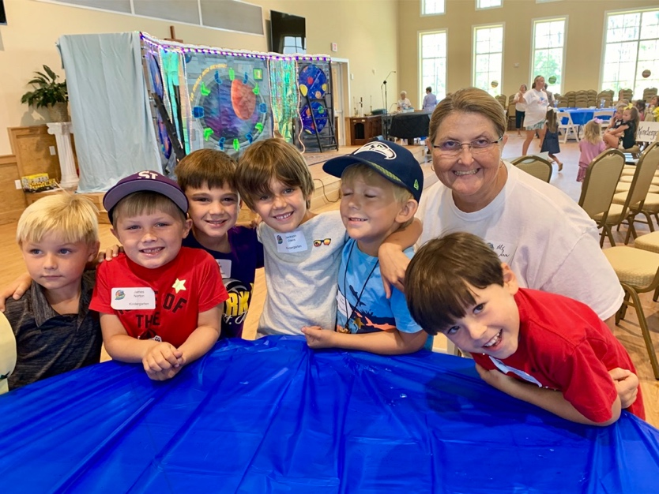

Vacation Bible School